Minutes for Mills Haven School and Student Enhancement Society

Call to Order
An MHSSES Council meeting of Mills Haven Elementary was held on November 19, 2019 at Mills Haven Elementary Library. It began at 6:01pm and was presided over by Sherry J. School Council Chair, with School Council Secretary, Becky M taking the minutes.
Attendees
Becky M.
Keri B
Garry R
Sherry J
Tanya L
Lisa H
Sarah G
Priya H

MHSSES Chair, Sherry Jones opened the meeting announcing that the two meeting being held tonight will take place in opposite order due to the School Trustee, Annette Hubrick, being unable to attend until later in the evening. By switching the timing of the two meeting Annette would be present for the School Council and School reports.

Approval of Minutes
CHANGES to October 8, 2019 meeting minutes:
- Account updates should read “End of September”
- An error has been noticed in the Treasurer’s Update excel document. Jodi will find the error and have the numbers add up correctly. Updates will be made to the September and October reports.
A motion to approve the minutes of the previous October 8th ,2019 meeting was made by Lisa H and seconded by Sherry J

Review of Agenda

Treasurers Report
Treasurer’s Report was created by Jodi S and presented by Sherry J.

Account updates:
- Casino account end of October 2019: $684.73
- MHSSES account Balance end of October: $16,522.39
Because an adding error was noticed in the Treasurer’s excel report, corrections will be made for the January meeting. The above account are correct because they are taken from the bank statements.
Becky M accepted the Treasurer’s account updates.

Chair Reports
Presented by Sherry J, Chair
- Hot Lunch:
- Hot lunch is going well

Milk:
Milk Program update was prepared by Anna M and presented by Sherry J
- Selling YOP again. Students were asking for it. Anna will do another Kik card count in December to see how many punches are left.
- Anna raised concern in her report about the cost of laminating the Milk cards. She recommended trying to print them on a heavier paper stock.
  - All board members agreed this was a great option.
- More volunteers are needed to pick up the empty container recycling. Sherry will send out a call for volunteers.

- Fundraisers:
  - Large Fundraiser- Purdy’s
    - Sherry has the fundraiser ready to begin today, November 19,2019
    - Ordering closes Wednesday, November 27th.
    - Fundraising Goal has been set for $4000
    - Delivery on December 10th-Tanya L and Lisa H can receive the order and sort. Sherry will send out volunteer call.
    - Order pick up will be on December 11
- School Fundraiser Support Reminders
  - Silver Bells Collection at Christmas Concert Volunteers will be needed to collect donations.
  - School will be running a front row seats Raffle from November 28-December 5. MHSSES will create license and collect funds to pay for the Christmas Concert Church Rental.
- Playground Update:
- Our Playground is slated for replacement in 2022
- Heather from the county (also a parent at Mills Haven) will come to the January meeting to give us more information
- Teacher/Student Council Presentation- Proposed T-shirt purchase
- Halloween Dance update:
- $435 Profit
- Expenses were a little overbudget, affecting the overall profit.
- Next year ticket sales will be done through Eventbrite. There was a lot of upset parents about the limited tickets and how they were sold. Using this sales site will eliminate the pressure on the committee volunteers.
- Silent auction went well.
School Council Chair asked if anyone had anything to add to the MHSSES meeting.
No members had anything to add.

Announcements
The next MHSC & MHSSES Meetings Tuesday, January 14,2020 at 6:00pm in the school library.

Adjournment
Sherry J moved that the meeting be adjourned, and this was agreed upon at 6:25pm.

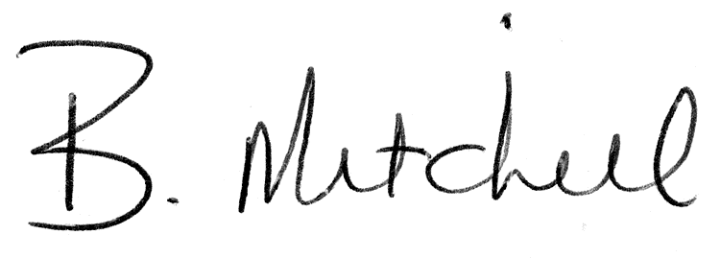
Secretary  Mills Haven School and Student Enhancement Society |  | Date of Approval

