Minutes for Mills Haven School and Student Enhancement Society

Call to Order
An MHSSES Council meeting of Mills Haven Elementary was held on September 11, 2019 at Mills Haven Elementary Library. It began at 7:15 and was presided over by Sherry J. School Council Chair, with School Council Secretary, Becky M taking the minutes.
Attendees
Becky M.
Keri B
Garry R
Sherry J
Laura G
Tanya L
Michael G
Laura D
Sarah G
Erin F
Caleb V

Approval of Minutes
A motion to approve the minutes of the previous June 12th ,2019 meeting was made by Sarah G and seconded by Sherry J

Review of Agenda

Treasurers Report
Treasurer’s Report was presented by Jodi S.

Account updates:
- Casino account end of August 2019: $688.63
- MHSSES account Balance end of February: $$18,333.11
2020/2021 Proposed Commitments driving the 2019/2020 fundraising year are as follows:
School Council has proposed a $13,000 fundraising goal for the 2019/2020 school year to support the commitments for the 2020/2021 school year. The rough breakdown is as follows
 | Budget
Cultural | $3,000
Gr 4. ESO | $400
Classroom Incidentals | $4,500
Carnival | $400
Artist in Residence | $2,600
Cones for Gr 1 | $1,000
Fasching | $500
St. Nikolaustag | $600
 | $13,000
- MOTION: Sherry J motioned to accept the proposed 2020/2021 Commitment goal to be fundraised in the 2019/2020 school year.
-All board members present in favour.
-MOTION PASSED
Becky M. accepted this report
NOTICE: Jodi S. gave notice of her resignation as MHSSES Treasurer. Due to changes in her life she is no longer able to give the Society the attention it needs. Jodi agreed to stay on as Treasurer until a new parent was able to fill the position.
Shery J accepted Jodi’s resignation and commitment to maintain the Treasurer position until it was filled.

Chair Reports
Presented by Sherry J, Chair
Requested for Multimedia equipment. The school has not heard back from either company yet.
- Hot Lunch:
  - New committee is doing well. Vendors are booked and website will open soon
- Looking for 6 Hot Lunch Leaders.

Milk:
- Getting started. Anna M is running Program.
- 130 Punches remaining on KIK Cards-Becky M will continue to buy KIK until all punches are used
- 126 milk punches have been donated to the school for students in need.
- Only White and chocolate milk will be sold this year
- Mr. Peters will oversea Grade 5 Milk Volunteers

- MOTION: Sherry J motioned to spend up to $30 per month on coffee creamers for the staff room.
-Motion is seconded by Tanya L
-All board members present in favor
-MOTION PASSES
- Fundraisers:
  - Large Fundraiser- Purdy’s
    - Committee Needed
  - 100% Fundraiser- Going home right away
    - Treasurer will collect funds
  - Halloween Dance-Family event and fundraiser to include concession, Silent auction items, admission sales.
    - Committee is in place
- School Fundraiser Support Reminders
  - Silver Bells Collection at Christmas Concert Volunteers will be needed to collect donations.
- Bottle Drive:
- Will take place at Parent Teacher Interviews. Truck will have to be ordered for second day. Parking place will have to be determined
- Teacher/Student Council Presentation- Proposed T-shirt purchase
- Sherry J started the discussion about the proposal in the School Council meeting by Grade 6 teacher Derek Z.
  - T-shirts have a cost of $17.20 per t-shirt. Derek is asking for 20 t-shirts for a total cost of $344.00.
- After a short discussion, all parents were in favour of supporting the Student Council with personalized t-shirts.

MOTION: Sherry J motioned to spend up to $400.00 on t-shirts for Mills Haven Student Council.
-Motion is seconded by Tanya L
-All Board members present in favour
-MOTION PASSES

School Council Chair asked if anyone had anything to add to the MHSSES meeting.
No members had anything to add.

Announcements
The next MHSC & MHSSES Meetings Tuesday, October 8,2019 at 6:00pm in the school library.

Adjournment
Sherry J moved that the meeting be adjourned, and this was agreed upon at 7:40pm.

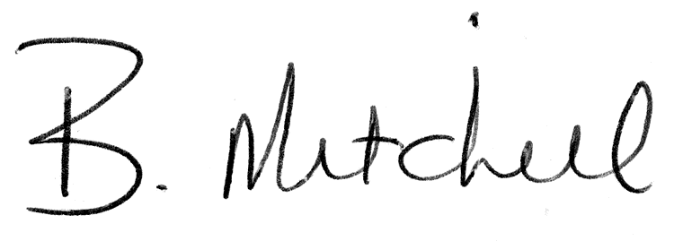
Secretary  Mills Haven School and Student Enhancement Society |  | Date of Approval

