Minutes for Mills Haven School Council

Call to Order
A School Council meeting of Mills Haven Elementary was held on March 13, 2019 at Mills Haven Elementary Library. It began at 6:11pm and was presided over by Sherry J School Council Chair, with Becky M School Council Secretary taking the minutes.

Attendees

Becky M.
Keri B
Sivanthy S
Connie L (GBA)
Sherry J
Tanya L
Anna M
Laura D (GBA)
Erin (GBA)
Becky M (GBA)
Michael S (GBA)
Laura G (GBA)
Jodi S
Caleb V
Michael G
Garry R
Ben S
Jodi S
Karen W
Ashley S

Approval of Minutes
No Changes
A motion to approve the minutes of the minutes from January 16th, 2019 meeting was made by Sherry J and seconded by Karen W

Additions to the Agenda
- Library Presentation
- Teacher Appreciation Day
School Trustee Report
Not Present

School Report
Garry Russel, Principal, provided school report

  - School will be operating on a 4% Budget for the 2019/2020 school year

  - Fees:
    - Garry presented the projected school fees for 2019/2020
    - **Please see final of page of minutes document for Projected Fees**
    - Field Trips had to be cut or costs increased due to consistent number of families not paying fees. The school is unable to carry the costs of field trips.

  - Students numbers for next year as of March 13/19
Grade | Total | Regular Program | German Cultural Program
Kindergarten | 70 | 51 | 19
1 | 58 | 42 | 16
 |  |  | German Bilingual Program
2 | 61 | 41 | 20
3 | 60 | 42 | 18
4 | 66 | 47 | 19
5 | 54 | 47 | 7
6 | 69 | 50 | 19

  - Linking Generations
    - Division 2: 4-5 Seniors coming to visit Div 2 kids. Garry is inquiring about having FNMI Elders attend as well

  - Supplies
    - Supply list done
    - Asking for supply delivery in June
    - Still allow orders in summer and deliver in August
  - Numeracy/Literacy
    - Mrs. Chapman put together Math Kits for classrooms.
    - School is inquiring about dice from casinos
  - Reader’s Workshop
    - $10,000 has been put towards the program for leveled reading
    - Books to arrive in June
  - Elder Wilson
    - Retiring next year
    - Celebration video made at Mills Haven elementary
  - Pancake Breakfast
    - Last Friday in May
    - Parent Volunteers needed
  - Artist in Residence
    - Mrs. Clark spent this year meeting with each class working on art projects. Some teachers use them as parents gifts.
    - Cost is about $3500
    - Asking School Council to pay
  - ASCA Conference
    - April 26-28
    - EIPS Paying for 1 person
  - Keri Shared Kudos from each class!

Treasurers Report
Treasurer’s Report is presented by Jodi S, Treasurer.
School Council End of January Account Balance: $5624.30
- Still to pay for: Artist in Residence, Grade 6 pictures, Cultural Events
Becky M motioned to accept Jodi’s School Council September Treasurer Report. Tanya L and Becky M Seconded the motion.

GBA Report
GBA Report presented by Laura G
- Stawnicky’s Fundraiser Flyers went out March 13/19. Last day for orders is March 21/19
- May 30 is Pretzel Day

Chair Report
Chair Report was presented by Sherry M.
- April 5 is Movie Night
- Need to pick movies
- Volunteers needed
- Summer Sizzler
- Sherry will send out a call for a committee to see if any families would like to run a year end BBQ or event
- Teacher Appreciation Day
- Becky M suggested
- Christmas Decoration
- New Christmas decorations are needed. After a brief discussion, parents agreed to donate personal decorations and School council will pay for some new ones.
- Amount to be motioned on in MHSSES Fundraising Meeting.
Open Discussion for new initiatives and ideas:
No new discussion or ideas.
Sherry J. moved that the meeting be adjourned, and this was agreed upon at 7:14pm.
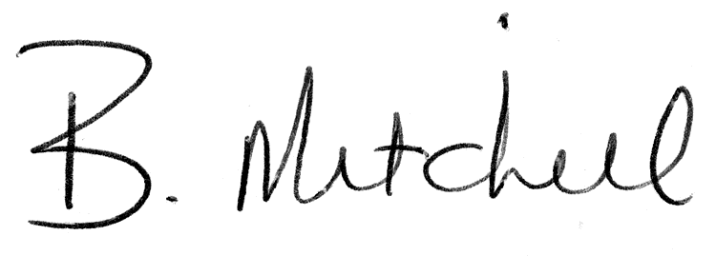
Secretary  Mills Haven School Council |  | Date of Approval

Mills Haven Elementary
SCHOOL FEE SCHEDULE
for the Year Ending August 31, 2020
 |  | (A)  Per Student Fee 2019-20 | (B)  Actuals in Acorn 2018-19 | (C)  Board Approved Per Student Fee  2018-19 | (D)  Board  Approved  Per Student Fee  2017-18 | (E)  (A - C)/C  % Change (between 2018-19 and 2019-20)
Extracurricular Fees
 | Ski Trip - Lift Ticket/snowboard rental, transportation | $ 43.00 |  |  |  | 100%
 | Ski Trip - Lift Ticket, ski rental, transportation | $ 40.00 |  |  |  | 100%
 | Ski Trip - Transportation only | $ 4.00 |  |  |  | 100%
 | Ski Trip - Lift ticket, transportation | $ 31.00 |  |  |  | 100%
Activity Fees
 | Field Trips - ECS | $ 76.72 | $ 97.00 | $ 97.00 | $ 80.75 | -21%
 | Field Trips - Gr. 1 | $ 81.79 | $ 84.00 | $ 84.00 | $ 81.00 | -3%
 | Field Trips - Gr. 2 | $ 80.96 | $ 72.00 | $ 72.00 | $ 67.00 | 12%
 | Field Trips - Gr. 3 | $ 77.36 | $ 76.00 | $ 76.00 | $ 70.00 | 2%
 | Field Trips - Gr. 4 | $ 70.35 | $ 88.50 | $ 88.50 | $ 72.00 | -21%
 | Field Trips - Gr. 5 | $ 80.30 | $ 84.00 | $ 84.00 | $ 82.00 | -4%
 | Field Trips - Gr. 6 | $ 55.63 | $ 46.00 | $ 46.00 | $ 46.25 | 21%
 | Young Author's Conference | $ 30.00
 | Elementary Track | $ 20.00
 | Wisest Choices U of A | $ 40.00
Lunch Supervision And Noon Hour Activity Fees
 | Noon Supervision | $ 100.00 | $ 100.00 | $ 100.00 | $ 100.00 | 0%

