Minutes for Mills Haven School Council

Call to Order
A School Council meeting of Mills Haven Elementary was held on November 21, 2018 at Mills Haven Elementary Library. It began at 6:08pm and was presided over by Sherry J School Council Chair, with Becky M School Council Secretary taking the minutes.

Attendees

Becky M.
Keri B
Sivanthy S
Connie L (GBA)
Sherry J
Tanya L
Anna M
Laura D (GBA)
Don I
Sarah G (GBA)
Erin (GBA)
Becky M (GBA)
Michael S (GBA)
Laura G (GBA)
Derek Z
Laura G (GBA)
Jodi S
Caleb V
Michael G
Garry R
Ben S
Ahsley S

Approval of Minutes
No Changes
A motion to approve the minutes of the previous October 10th, 2018 meeting was made by Erin F and seconded by Sivanthy S

Additions to the Agenda
- Christmas Decorations
New Year Introductions for everyone at the meeting
School Trustee Report
School Trustee Report was presented by Don Irwin, Trustee:
Will be sending link to Trustee report for minutes
- Most important to note that School enrollment is up for the 2018/19 school year.
- New curriculums are being reviewed.

School Report
Garry Russel, Principal, provided school report

  - School Population: 452 students with 124 enrolled in German Bilingual Program

  - Fees:
    - Garry explained that school fees vary per grade because of field trips
  - Christmas Concert:
    - December 13- evening only concert
    - 3 tickets per family will be issued. Extras will be given out as unneeded tickets are returned.
    - Silver Bells collection-School Council will be organizing volunteers for the collection
  - School Photos
    - Garry asked present parents if they were satisfied with the current company. Parents agreed the current company was fine. The school will go ahead and hire the same company for next year

  - Highlights of School Pillar Reports
    - Mills Haven scored high on results for Safe and Caring School, Parent Involvement and PAT results.
  - Numeracy/Literacy
    - Consultants are coming into the school to work with teachers.
  - Reader’s Workshop
    - $8000 has been put towards the program!
  - LLI
    - Kerri B, Vice Principal, is working with students in this program
  - ELL
    - Pia Jampen and Barb Davis are working with students in this program. Mills Haven currently has 22 children in the program.
  - Christmas Community Work
    - Students will be delivering bags door to door in the community for Food Bank donations. Students will then return the following to pick up donations left on front step.
  - Daily Mission
    - November is working on being courageous.
  - High Achievers
    - All grades and classes are working with Mathletics and Prodigy. Students are enjoying the online programs immensely!
  - Choice Conferences
    - 6 Grade 6 girls will sent to this conference to learn more engineering.

GBA Report
- Laura G presented GBA yearly fundraising and spending amounts after concern about the amount of fundraising at Mills Haven. Parents present discussed the concern and how better to present fundraiser information and financial needs to families.

Treasurers Report
Treasurer’s Report is presented by Jodi S, Treasurer.
School Council End of October Account Balance: $10,712.35
Becky M motioned to accept Jodi’s School Council September Treasurer Report. Tanya L and Anna M Seconded the motion.

Chair Report
Chair Report was presented by Sherry M.
- Class Representatives Still Needed
- Grades 1 and 5
- Sherry will look at sending home requests to the families in those grades
- Staff Christmas Basket
- After Discussion it is decided that School Council and GBA funds will be pooled to purchase staff gift.
- Amount To be motioned on in MHSSES Fundraising meeting
- Winter Play Day
- Sherry asked if parents would like to organize this free outdoor event this year. Parents agreed to keep it on the agenda to discuss in January.
- Christmas Decoration
- New Christmas decorations are needed. After a brief discussion, parents agreed to donate personal decorations and School council will pay for some new ones.
- Amount to be motioned on in MHSSES Fundraising Meeting.
Open Discussion for new initiatives and ideas:
No new discussion or ideas.
Sherry J. moved that the meeting be adjourned, and this was agreed upon at 7:14pm.
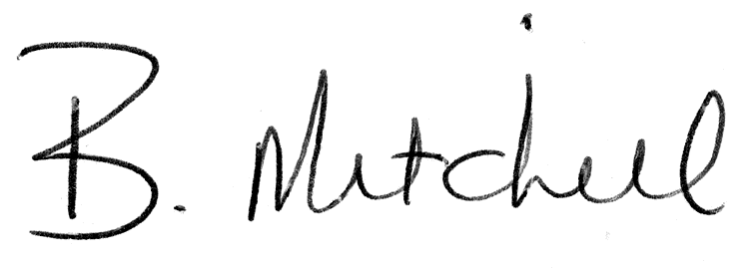
Secretary  Mills Haven School Council |  | Date of Approval

