Minutes for Mills Haven School and Student Enhancement Society

Call to Order
An MHSSES Council meeting of Mills Haven Elementary was held on Nov 21, 2018 at Mills Haven Elementary Library. It began at 7:15 and was presided over by Sherry J. School Council Chair, with School Council Secretary, Becky M taking the minutes.
Attendees
Becky M.
Lisa H
Sivanthy S
Garry R
Caleb V
Sherry J
Tanya L
Jodi S
Anna M
Derek Z
Ben S
Sivanthy S

Approval of Minutes
A motion to approve the minutes of the previous October 10th ,2018 meeting was made by Sherry J and seconded by Sivanthy S.

Addition to Agenda
- Rocks and Rings and School Jersey’s

Treasurers Report
Treasurer’s Report is presented by Jodi S, Treasurer.
MHSSES End of September account balance: $21,623.34
Casino Account end of September balance: $18075.41
Becky M accepted the Treasurer’s Report
MOTION #1: Jodi S motioned to spend up to $100 on the Staff Christmas Basket. The motion was seconded by Sherry J.
Vote: All in Favor
MOTION PASSES: to spend up to $100 on the Staff Christmas Basket.

MOTION #2: Jodi S motions to spend up to $100 on new Christmas decoration. The motion was seconded my Becky M.
Vote: All in Favor
MOTION PASSES: to spend up to $100 on new Christmas decoration.

Chair Reports
Presented by Sherry J, Chair
- Mom’s Pantry Fundraiser
  - UPDATE: Fundraiser went really well. Total funds raised were $4328.05

Update on Email Voting
No email votes in October
- School Jersey’s
  - Derek Z presented the new school jerseys purchased by School Council Casino Funds. One of the sets was not printed to Derek’s liking. He is going to inquire with company about having the Jersey’s replaced.
- Rocks and Rings
  - Rock’s and Rings Program was at Mills Haven Elementary and every grade loved the activity! Derek is inquiring about purchasing 2 Rocks and Rings sets at a cost of $2284 +GST. This would allow 28 students to play at once. This activity could be added to the physed/DPA classes as well as allow Division 1 students to participate in intermurals.
  - All parent present discussed the purchase and agreed it is something the Casino Funds could support.
MOTION #3: Jodi S motioned that the Casino Fund spend up to $3000 to purchase 2 Rocks and Rings sets. The motion was Seconded by Sherry J.
Vote: All in Favor
MOTION PASSES: to spend up to $3000 on 2- Rocks and Rings Sets.

- Hot Lunch: Update by Becky M
    - Everything is going really well

Milk:
- Program is going well.
- Grade 4 students are now helping with the container recycling. Because the recycling is being put out later, keys will need to be cut for the volunteers to access the bags after hours.
- Karen will take care of getting the keys cut.

- Christmas Concert Silver Bells Collection:
- School Council is no longer paying for the concert but will provide volunteers to the school for the collection this year.
- Volunteers will once again have first pick of their seats at concert.
- VOLUNTEERS: Sivanthy, Becky, Sherry, Crystal.
- Sherry will send home email to find more volunteers
Upcoming Fundraiser/Events
- Movie Night in April
- Spring Bottle Drive

School Council Volunteer needs for 2018/19
- Movie Night in April: Volunteers will be needed to pop popcorn during the day and for the concession in the evening.
- Spring Bottle Drive: volunteers will be needed through out the day to greet families dropping off empties.

School Council Chair asked if anyone had anything to add to the MHSSES meeting.
No members had anything to add.

Announcements
The next MHSC & MHSSES Meetings Wednesday, January 16th at 6:00pm in the school library.

Adjournment
Sherry J moved that the meeting be adjourned, and this was agreed upon at 7:46pm.

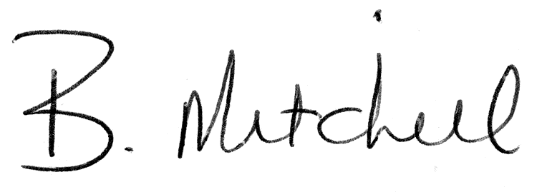
Secretary  Mills Haven School and Student Enhancement Society |  | Date of Approval

